**DATABASE MANAGEMENT SYSTEM**

**SEMESTER- IV**

**LAB SHEET- 03**

**NAME:** Neeraj Avinash Chormale

**PRN:** 20220802071

**Batch:** A2

**Aim:**

* Create department table, employee table in MySql.
* Create project table with primary key
* Create workson table
* Create foreign keys between employees and department
* Create foreign keys between workson and employees
* Create foreign keys between projects and departments.

**Experiment and Results:**

1. Create employee table, department table in MySql.

1. Create project table with primary key.

1. Create workson table.

1. Create foreign keys between employees and departments.

1. Create foreign keys between workson and employees.

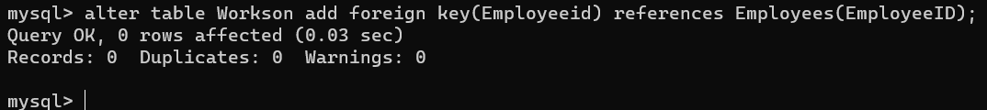

1. Create foreign keys between projects and departments.

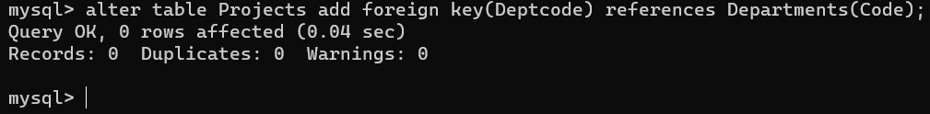

**Conclusion:**

In conclusion, the provided SQL commands effectively establish a relational database schema for managing department, employee, project, and workson data. By defining tables with primary keys and establishing foreign key constraints between them, the schema ensures data integrity and maintains referential integrity across related entities. This setup enables the database to efficiently organize and store information while enforcing relatioships between entities, thus facilitating effective data management and retrieval operations.